Title of the Paper

AUTHORS
Authors Contact Information

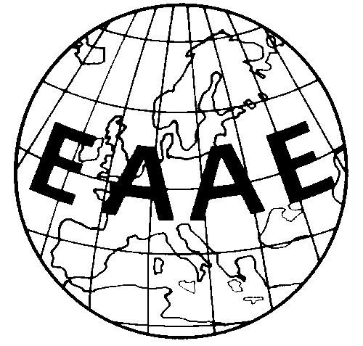

Paper prepared for presentation at the 147th EAAE Seminar ‘CAP Impact on Economic Growth and Sustainability of Agriculture and Rural Areas’, Sofia, Bulgaria, October 7-8, 2015

Copyright 2015 by [authors]. All rights reserved. Readers may make verbatim copies of this document for non-commercial purposes by any means, provided that this copyright notice appears on all such copies.

